Lab: MLOps Integration using Flask, MongoDB, MLflow, and Docker Compose

The objective of this lab is to develop and containerize a complete Machine Learning web application that integrates:
- Flask (as backend API & web server)
- MongoDB (as data storage for inputs and predictions)
- MLflow (as model tracking and experiment management platform)
- Docker Compose (to orchestrate multiple containers)
Problem Statement:
The university wants to predict whether a student will pass or fail based on their study and sleep habits.
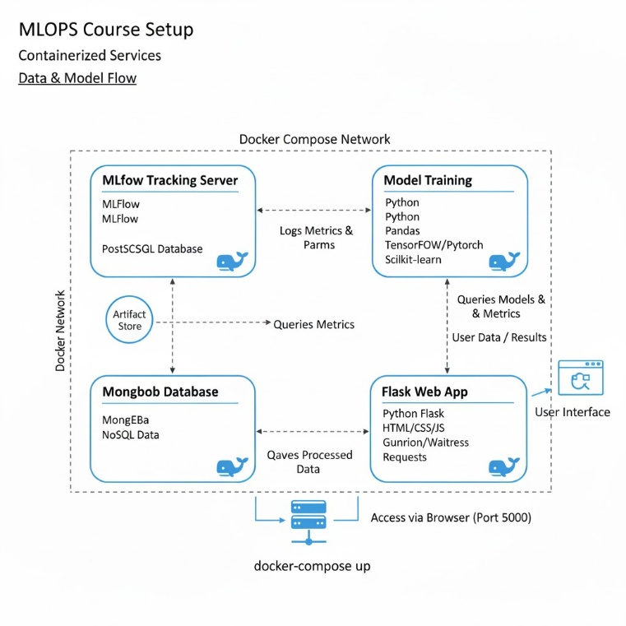
You are required to build a web-based ML system with the following characteristics:
- Flask web interface accepts input values:
  - study_hours
  - sleep_hours
- The backend Flask API:
  - Fetches the latest trained model from MLflow.
  - Generates a prediction (passed or failed).
  - Stores both the input and predicted output in MongoDB.
- A separate training container trains the model using existing data and logs:
  - Model parameters
  - Accuracy
  - Trained model artifact to MLflow tracking server.
MLFLOW:
An MLflow container runs the MLflow Tracking Server — a web service that lets you:
- Track experiments (parameters, metrics, models, artifacts)
- Register and version models
- Serve models later (optional)
Instead of running MLflow locally (mlflow ui), we’ll run it inside Docker
- Components
MLFlow setup contains a) Tracking Server b) Artifacts(Stores actual models and files (e.g., local volume, S3).
The directory structure is as follows:

mlflow_server/
├── Dockerfile
├── artifacts/ # Folder where ML models and runs are stored
└── entrypoint.sh # Script to start MLflow server
- Dockerfile
# File: mlflow_server/Dockerfile
FROM python:3.10

WORKDIR /mlflow

# Install MLflow and dependencies
RUN pip install mlflow==2.14 psycopg2-binary boto3

# Expose port 5000 (MLflow UI)
EXPOSE 5000

# Copy entrypoint script
COPY entrypoint.sh .

# Make script executable
RUN chmod +x entrypoint.sh

# Default command
CMD ["./entrypoint.sh"]

- entrypoint.sh
#!/bin/bash
echo "Starting MLflow Tracking Server..."

mlflow server \
--backend-store-uri sqlite:///mlflow.db \
--default-artifact-root /mlflow/artifacts \
--host 0.0.0.0 \
--port 5000

- docker-compose.yml
version: “3.8”
services:
mongo:
mlflow:
build:
context: ./mlflow_server
container_name: mlflow_server
restart: unless-stopped
ports:
- "5001:5000" # host:container
volumes:
- ./mlflow_server/artifacts:/mlflow/artifacts
- ./mlflow_server/mlflow.db:/mlflow/mlflow.db
web:

- Trainer Container:
├── trainer/
│ ├── Dockerfile
│ └── train_model.py

So practically you will be building 4 containers, one for mlflow and to server, second for model training , third for mongodb and last one for flas_web.

